**Decision Trees:**

DT is basically a nested if else classifier.

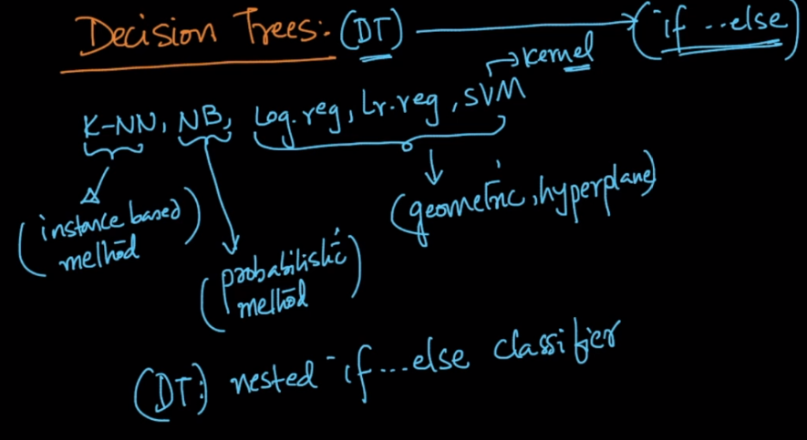

Let’s take an ex of Iris dataset, here we are creating nested if else for classifying,

If we draw this nested if else on a tree data structure, then it would become decision tree.

Here **root node and each internal node** is a **decision node**, where we are placing if else conditions, and **leaf node is result node**.

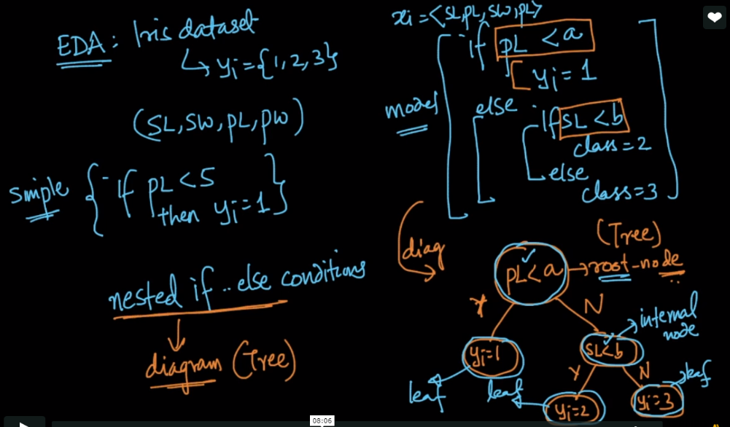

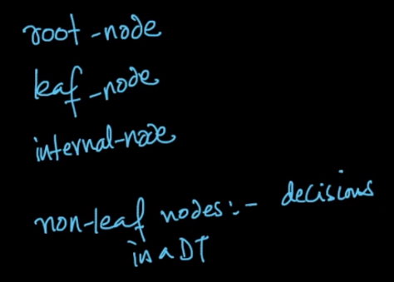

Let’s look at the gemotric intuition of DT.

Here we are just drawing axis parallel lines, one by one according to decision nodes as we are going from top to bottom.

So DT makes so many hypercubes or hypercuboids which classify them.

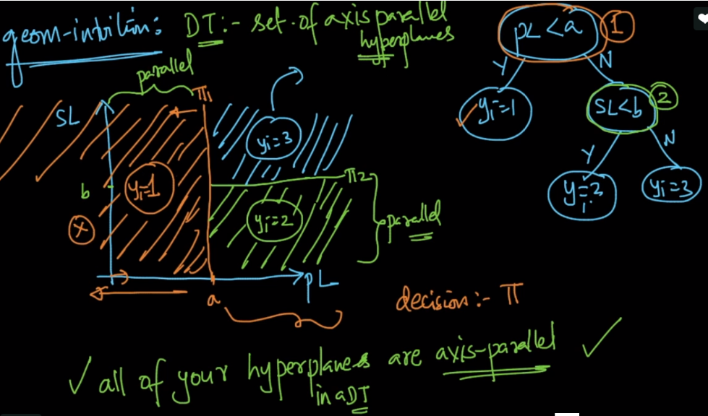

So we can say, nested if-else is programmatic way.

And set of axis parallel is geometric way.

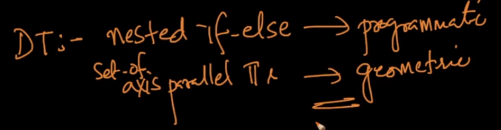

A very nice visualization of DT: <http://www.r2d3.us/visual-intro-to-machine-learning-part-1/>

**Decision trees are non-linear:** <https://datascience.stackexchange.com/questions/6787/are-decision-tree-algorithms-linear-or-nonlinear>

**One of the biggest advantage of DT is that it’s very much interpretable.**

**Comments:**

**1)**

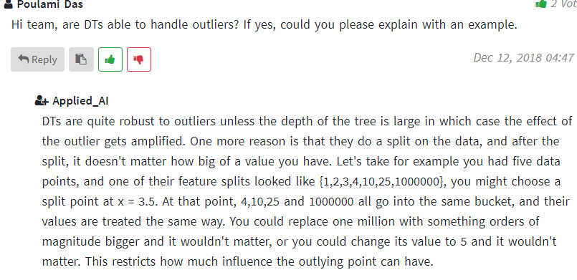

2)

